***SPANNING TREE PROTOCOL (STP)***

1. Apply STP on the given LAN switches and find out which ports are Root Ports, Designated Ports, or Blocking Ports.

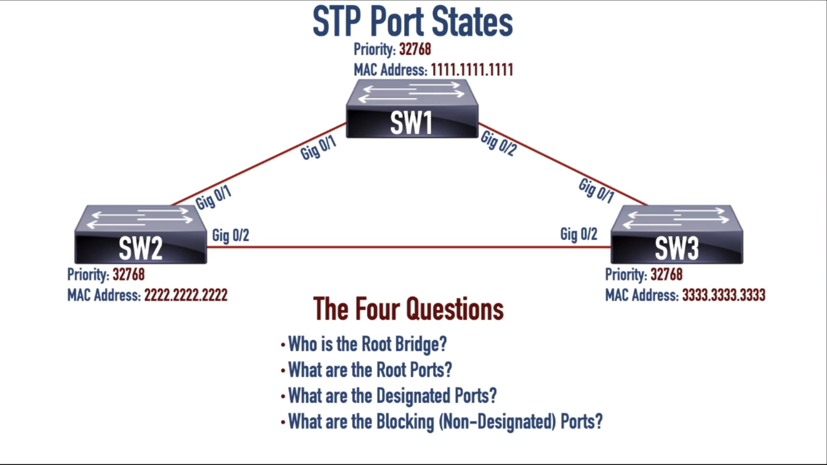



1. Apply STP on the given LAN switches and find out which ports are Root Ports, Designated Ports, or Blocking Ports.

